Q.P.A. Curriculum Statement

‘Empowering every child with a rich variety of knowledge, skills and opportunities; enabling them to progress in school and throughout their lives.’

We promote the highest standards across all elements of school life in order to ‘Empower and Enable’ our pupils to have optimum life chances. We ensure our pupils are ready to take the next steps of their development into secondary school through a broad and balanced curriculum, including:

Setting the highest standards in every element of school life:
‘High Expectations Lead To High Achievers’.
Fostering positive relationships across the school community, treating all pupils with unconditional positive regard.

Developing responsible citizens within British Society
Developing strength of character to ensure resilience and personal development

Identifying, celebrating and rewarding achievement and individual successes.
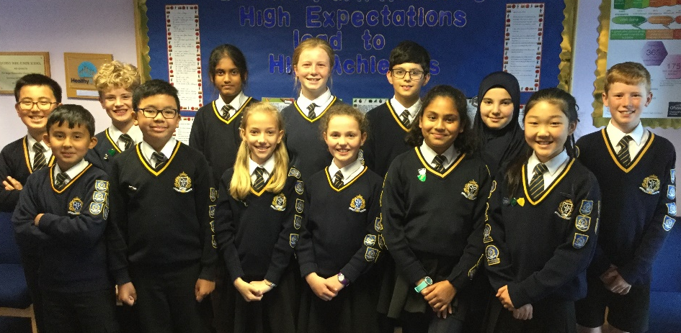
Developing interests through exposure to a wide variety of first-hand experiences

Linking and embedding learning through integrated half termly projects
Securing effective core ability in reading, writing and maths and providing opportunities for mastery.

Engaging lessons, adapted to each child’s needs, to ensure every child succeeds.

Continued professional development of all staff subject knowledge, allowing them to provide high-quality learning opportunities and the best outcomes for children.
Knowledge, creativity and skills development to promote excellence and enjoyment of learning, and as a foundation to future learning

High Expectations
Our school mantra of ‘High Expectations Lead to High Achievers’ permeates all we do at QPA, both inside and outside of the classroom. We believe in the abilities of our pupils and promote positive behaviours for learning that result in success across all fields of school life. Achievement is recognised and success celebrated through our reward systems and processes, reinforcing the power of learning to our pupils.

Knowledge
We use the National Curriculum as a framework for learning, on which we build the learning of wide and rich knowledge, which is then applied as skills.
We consider learning knowledge across all subjects to be essential in the empowering of our pupils:
- Children use knowledge to understand, make sense of and interpret the world.
- Shared knowledge enables children to cooperate effectively.
- The foundation for a just and sustained democratic society is shared knowledge.
- It is fair and just that all children should access knowledge.
Due to its importance, knowledge is explicitly planned for, as well as the skills that will utilise this knowledge.

Linking and Embedding Learning
Within our aim to enable and empower our pupils, we understand how forming links between knowledge and concepts is essential to long term learning. Our curriculum projects are carefully planned to allow for sequences of learning that build up knowledge over time and that link learning across different subject areas, including literacy and numeracy. Each topic that the pupils learn consists of a ‘primary’ subject area, and other subject areas, all of which interlink to contextualise the areas being learned and embed this learning, allowing for the development of complex ‘schema’ for our pupils. The curriculum ‘diet’ of the school is set out in long term, medium term and short term plans, with progression and assessment opportunities highlighted.

Reading, Writing and Maths
We understand that having a secure ability in Reading, Writing and Maths is essential to our pupils’ ability to learn independently in their time at QPA and into their future lives.
Our delivery of Reading and Writing is integrated into the teaching of our topics, in order to be relevant and based on the context of a child’s wider learning. We teach Reading through the use of a topic-based class text daily and through comprehension lessons, as well as through individualised interventions and reading support. Reading is taught using the VIPERS (Vocabulary, Inference, Prediction, Explanation, Retrieval and Summarise) approach which focus on teaching the essential skills of comprehension. Writing is taught in classes, with grammar learning embedded into teaching in order to ensure understanding of the relevant content. Spelling is taught daily through short, focussed sessions matched to the year group’s curriculum. Reading and spelling is underpinned through the teaching of phonics.
Maths is taught daily using the ‘Power Maths’ DfE approved scheme, which is based around an investigative, problem solving approach in line with the Singapore pedagogy.
To further support learning, our teachers hold additional learning ‘extended schools’ sessions for any learner that requires support with elements of learning in reading, writing and maths. Pupils attending and subjects covered vary in relation to the specific need within the year group, as determined through ongoing assessment of the pupils on the school’s assessment system.

Support
We support all our pupils to achieve their best and to enable and empower. All pupils at Q.P.A. are treated with unconditional positive regard, with each individual member of our community valued. This approach is matched within our positive behaviour for learning policy.
Alongside a skilled Learning Support Team, our Inclusion Team provide pastoral care to pupils who are experiencing challenge within their own lives and may be vulnerable. This team also support pupils when transferring to secondary schools and are all level 3 safeguarding trained to allow for secure child protection procedures and practices to be implemented effectively.

Experiences
We place a high level of importance on our pupils being active within their learning. This involves a wide variety of activities within the classroom, but also a wide variety of other opportunities to learn and develop. Each half term, pupils participate in immersive experiences in order to engage, stimulate curiosity and add context to their learning. This can be trips to museums, wildlife centres and other areas of interest, visitors to school or themed days linked to their topics.
Additionally, we run a wide variety of after school clubs that are free of charge (for example, cookery, hockey, football, tennis) as well as offering the opportunity to participate in other paid for clubs on site.
Residential experiences are held in every year group, with pupils staying for one night in Year 3, two nights in Year 4, three nights in Year 5 and a whole week in Year 6. These experiences empower our pupils through developing independence, problem solving, cooperation and self-regulation, as well as developing knowledge through being directly linked to the topics being studied within the year groups.

Avenues to future learning
One of our key aims is for our pupils to develop a love of learning and to be ambitious within their own goals for the future. Within our curriculum, we explore a wide range of subjects in detail, celebrating the children’s particular strengths and abilities and fostering enjoyment within different subject areas. We provide further inspiration through the celebration of the lives of key individuals within our topics and hold a Careers Day for our Year 6 pupils to explore the direction that the children would like to travel. Some of our pupils and families wish to gain entrance to local Grammar Schools, which we support through additional, after school sessions.

Citizenship
Our pupils are taught core British values throughout their school experience. This is developed within teaching, for example through History lessons that are largely focussed on British History, through assemblies, within PSHE learning (using some resources from the ‘SCARF’ scheme) and through our relationships with our pupils. We have an active school council who model the democratic process to our pupils and also empower our Year 6 pupils through encouraging them to take roles of responsibility as prefects, house captains and monitors. RE forms part of our citizenship lessons. Children are encouraged to explore their own beliefs and build respect for the beliefs of others through investigating open questions linked to the 6 main world religions.

Character Development
We enable and empower our pupils through development of the child as a whole, which not only considers academic development, but also social and personal. Our Character Award Program is integral to this. Pupils are introduced to different characteristics within assemblies and class activities and then rewarded when they demonstrate these traits positively. We have categorised twelvecharacter traits that we want our children to develop: trust, compassion, self-control, courage, interdependence, mindfulness, curiosity, grit, adaptability, sportsmanship, creativity and optimism.

Reflection, Evolution and Adaptation
We value the importance of reflection about the learning of our pupils and how to best alter our curriculum provision to meet the needs of the children that we teach. We continually assess pupils and use this information to plan lessons in all subjects. Additionally, through curriculum reports, we highlight key areas of development for our pupils from across the range of subjects covered, identifying actions to address gaps in learning for groups or cohorts of children. Furthermore, we run curriculum INSET for at least two days a year, in order to continue to develop the quality of our provision.

